Lightning Talk Title

Presenting Author Name¹, Other Author¹, Other Author¹, Corresponding Author Name^{1,*}

¹School of Data Sciences, Perdana University, Malaysia

Presenting Author: janedoe@perdanauniversity.edu.my;
*Corresponding Author: johndoe@ perdanauniversity.edu.my

The abstract should be prepared in PDF on A4-sized page format. Total printable word count should not exceed 250 words (excluding title, author names and address). Also please make sure the full abstract does NOT go beyond one page. If needed, one figure may be included at the end of the abstract (before references, if any). Print quality figures with at least 600 dpi resolutions should be used. Line drawings should have 1200 dpi resolution. More than one figure can be included as columns in a table as in the template. Abstract should be written in Times New Roman font. Abstract text title, author names, author address and images should be centre-aligned. The main abstract text should be justified. Font size should be 12 point for the main text and 16 point for the title. Presenting author names should be underlined. Corresponding author name should be marked with an asterisk (*) in superscript. Email address of presenting author and the corresponding author should be provided. All affiliation addresses should be italicized. An abstract is supposed to be a stand-alone piece of work; therefore, references should be avoided, but if essential, then cited by numbers and squared brackets inside the text. They should be cited in the order of their occurrence. Also, non-standard or uncommon abbreviations should be avoided, but if essential they must be defined at their first mention in the abstract itself. For Demo submissions, please include additional information, such as the availability and requirements of the software/technology/database/tool, if any.

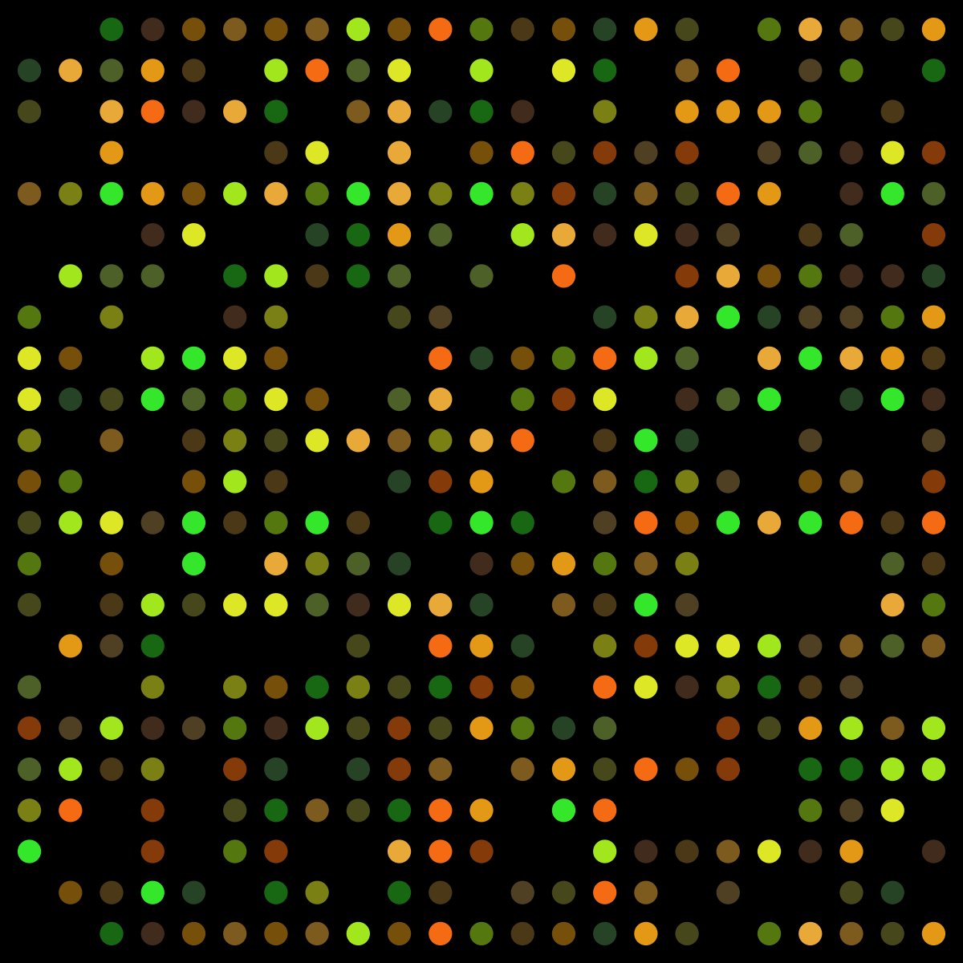 | 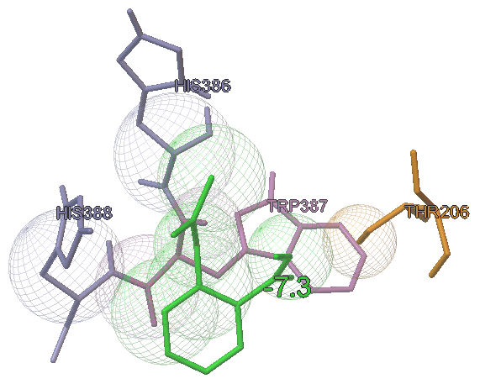 | 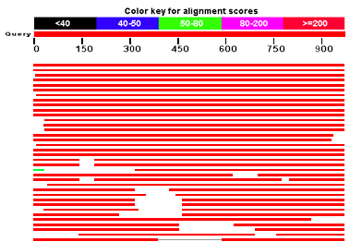
Figure 1: Caption | Figure 2: Caption | Figure 3: Caption

[Only if necessary]:
References
[1] A. Divoli, T.K. Attwood. Bioinformatics 21 (2005) 2138-2139
[2] S. Das, C. Orengo. Structure 26 (2018) 528-530

Use italics for journal name, bold font for volume number and brackets for year of publication. Only list the first two authors; if more add “and et al.”

